Refinery Profit Maximization

EBGN-645
FALL 2025

Final Project
Abdulrahman Alturki
12/15/2025

Table of Contents:
Executive Summary 3
Introduction: 4
Literature Review: 5
Methods: 6
Assumptions Formulation Difficulties, and Data Resources 10
Results Summary & Interpretation: 12
Conclusion: 15

Executive Summary
The project develops an integrated LP/NLP/MCP modeling structure to assess refinery operations under multiple market conditions and economic situations. Refinery plays a critical role in the energy sector by processing the crude and converting it to more valuable products, which is called refined products. Such products can be utilized for daily essential needs such as supplying fuels for operating industries, facilitating transportation, and meeting necessary life needs.
The LP model determines the optimal output levels under fixed price, while NLP part captures total welfare/surplus based on the supply and demand curves, by looking at their intersection point. The MCP part expands to the full market equilibrium, where quantities and prices adjust until neither producer nor consumer have further incentives to change their decisions. As capacity constraint is the main driver here for the equilibrium point, the model identifies the prices corresponding to total crude processing rate of 140,000 bbls/day based on the pre-defined allocation of US and Brent barrels, and the products cover certain customers in the area (A &B).
Results show strong economic incentives for running the refinery at its maximum capacity, and this is attributed to the high profit margin associated with area high demand. This model acts as a robust tool for analyzing refinery performance addressing all market and environmental conditions.
The next step for this model is to expand the optimization domain covering the city or even the country (the entire supply chain network), in addition to incorporating maintenance schedules, demand forecast, advancing monitoring tools, and sensitivity cases. This would help to reach higher customers satisfaction level and more reliable and optimized operations.

Introduction:
The energy sector is a major part of global economic development, supplying fuels for operating industries, facilitating transportation, and meeting necessary life needs. In that sector, refineries play a major role as they convert crude into refined products such as gasoline and middle distillate (MD), in which their operations are sensitive to crude price fluctuations, crude availability, operational reliability, environmental regulations, and processing capacity limitations. Providing these challenges, optimization models have been critical tools for planning production, scheduling maintenance activities, controlling costs, running sensitivity cases, and enhancing operational and logistical decisions. The model shows how refinery is flexible to adjust its product yields (quota allocated for each product) by adjusting the operating philosophy depending on the capability of downstream units of Crude Distillation Unit (CDU).
Thus, the objective of this project is to investigate how an integrated LP, NLP, and MCP modeling structure can assess refinery performance, optimize product allocation, and measure market output levels under capacity constraints and crude supply availability. The aim of this study is to show how the most optimum refinery in a certain area generates profit and adjusts production figures in response to market challenges and across several scenarios to demonstrate how production levels (outcomes) vary across LP, NLP, and MCP structures.
The following figure simplifies the idea of refinery operations:
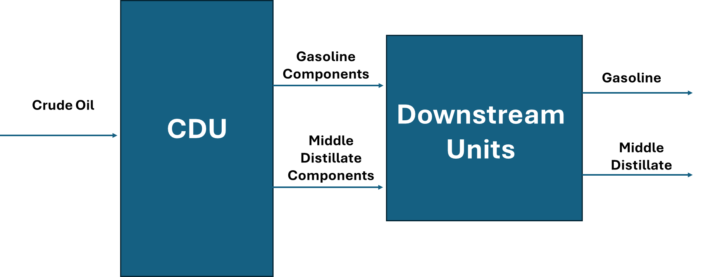
Figure 1: Simplified Refinery Processing Sketch

Literature Review:
The motivation for this project comes from the increasing complexity of global markets and the need for modeling programs that centralize technical refinery decisions with real market responses, to capture opportunities and achieve value creation. Most interestingly, this scenario assumes this refinery utilizes advanced technology to produce the most cost-effective refined products in the area compared to other supply nodes, in which it has been given the highest priority for optimization.
Typically, refinery optimization is done through sophisticated model that generates the output levels. Starting with the LP part, which is the fastest and simplest, that decides how much crude is processed and what are the production levels under fixed cost conditions and simple linear relationships. This part can be used as a first indicator for refinery planning strategy, and it is commonly used because of its simplicity.
If we go deeper into the downstream unit and see how their operations set depends on the relationship between temperature, pressure, and flow rate. It is worth noting that these relationships are nonlinear in most cases, and this emphasizes the importance of incorporating the NLP to indicate the optimum units’ rate, that lead to the total production amount of each product. On the other side, demand fluctuations (e.g. seasonality or shocks) may result in nonlinear behavior.
As for the market condition, product prices and output levels keep adjusting based on the supply and demand quantities, and to reflect this relationship we need to include the MCP part. The basic idea of this part is to show how price and quantity produced adjust until the market reaches balance or constraints are binding, and we can notice how output levels change. MCP adds the economic perspective to the model by linking the operational decision (output levels) to market dynamics.
The three different approaches (LP, NLP, and MCP) establish the basis of how refinery operations are optimized and represented in a structured way under several assumptions and conditions. Most importantly, this comprehensive model shows how operational capability and economic conditions influence output levels.

Methods:
This section illustrates the mathematical concept used in LP, NLP, and MCP parts of the refinery model. The purpose of this approach is to show the functionality of each part, its purpose, and how it can be interpreted.
- Model Basis:
Basically, the model includes the following:
- Two products: Gasoline and MD.
- Two sources of crude oil for processing: US and Brent.
- Two customers of products: A and B.
The model has several inputs as listed below:
- Reference product price (P_AVG(i)).
- Reference quantity price (Q_AVG(i)).
- Product average prices for a certain customer (Pc_AVG(i,u)).
- Product average quantities for a certain customer Qc_AVG(i,u)).
- Refinery processing capacity. (X_rate(s))
- Crude prices for two different sources. (W_avg )
- Crude supply elasticity and products demand elasticity (elas_supply_crude(s) & Elasticity_Dc(iu)).
The model consists of LP, NLP, and MCP as illustrated below:
Sets/ Indices
- Products i € {G,MD}; G=Gasoline, MD=Middle Distillates (Diesel & Jet Fuel);
- Crude Sources s € {US, Brent}
- Customer types u € {A, B}

- Main Functions:
To show the dynamic relationship between prices and quantity under equilibrium, the model has utilized supply and demand functions shown below:
Demand function: P(D)_{i} = a(i) – b(i)*Qi

Supply function: P(S)_{i} = c1(i) + d(i)*Qi
$$Qi=\frac{P-c}{d}$$

At Equilibrium: a(i)–b(i)* Q(i) = c1(i) +d(i)Q(i) , $Q(i)=\frac{a(i)-c1(i)}{b(i)+d(i)}$

We can identify slopes from elasticity as shown below
Demand Slope:
$b(i)= |{Elasticity }_{D} \left(i\right)|*\frac{P_{avg(i)}}{Q_{avg(i)}} , Note: ∈_{D} is usually negativ$e
Demand Intercept:
a(i)= $P_{avg(i)}$ + b(i)* $Q_{avg(i)}$
Supply Slope:
$$d(i)= |{Elasticity }_{S}\left(i\right)|*\frac{P_{avg(i)}}{Q_{avg(i)}} , Note: ∈_{S} is usually positive$$
Supply Intercept:
c1(i)= $P_{avg(i)}$ - d(i)* $Q_{avg(i)}$

Region Demand Slope:
$$b_c(i,u)= |{Elasticity }_{Dc} \left(i,u\right)|*\frac{P_{avg(i,u)}}{{Qc}_{avg(i,u)}} , Note: ∈_{D} is usually negative$$

Region Demand Intercept:
a_c(i,u)= ${Pc}_{avg(i,u)}$ + b_c(i,u)* ${Qc}_{avg(i,u)}$

Thus, the intersection between supply and demand curves is the equilibrium point. Now, we will go over each part to show how calculations are done:

- LP Part (Profit Maximization):
LP mainly targets to increase profit under fixed prices:
Variables:
- Qi: quantity produced of each product.
- K: Total refinery throughput

Constraints:
Throughput limitation:
$K= \sum{Q\left(i\right)}$
Crude Availability
$K≤ \sum{X_rate\left(s\right)}$
Product cut
$0.3K ≤Q(i)≤ 0.7K$

Profit Maximization Function
max$π$ = $\sum{(Pavg,i}$ * Qi) – Wavg * K - C₀
Based on this equation, revenue is calculated based on the summation of quantities of each product times its corresponding price. As for cost, it has been calculated based on the fixed cost (e.g. labor, administrative, power consumption, etc....) and weighted average cost of crude barrels processed.
- NLP Part (Total Surplus Maximization):
Utilizing the same constraints identified in the LP part, but with different objective function, the NLP part calculation has been performed. The total surplus is calculated based on the summation of consumer surplus (buyer’s benefit) and producer surplus (supplier’s benefit). Details are shown below:
$$CS=\int_{0}^{Q}{\left(Pd(i)-P^{*}(i)\right)dq=}\int_{0}^{Q}{\left(a_c(i,u)-b_c(i,u)q(i)-P^{*}(i)\right) dq(i)=a_c(i,u){Qc}^{*}(i,u)-\frac{b{{_c(i,u)(Qc}^{*}(i,u))}^{2}}{2}-P^{*}(i)Q^{*}(i)}$$

$$PS=\int_{0}^{Q}{\left(P^{*}(i)-Ps(i)\right)dq=}\int_{0}^{Q}{\left(P^{*}\left(i\right)-\left(c1\left(i\right)+d\left(i\right)q\left(i\right)\right)\right)dq(i)=P^{*}(i)Q^{*}(i)-c1(i)Q^{*}(i)-\frac{d(i){{(Q}^{*}(i))}^{2}}{2} }$$

$$TS=a_c(i,u){Qc}^{*}(i,u)-\frac{b_c\left(i,u\right)*({{Qc}^{*}(i,u))}^{2}}{2}- c1(i)Q^{*}(i)-\frac{d(i)({Q^{*}(i))}^{2}}{2}$$

For demand coefficients (a_c & b_c), we used i,u to show that the model has two demand curves
We calculate CS to quantify buyer’s benefit, (area between demand curve and equilibrium price line) and PS to quantify seller’s benefit (area under supply curve and equilibrium price curve). The equilibrium point is the intersection between supply curve and demand curve as shown below:
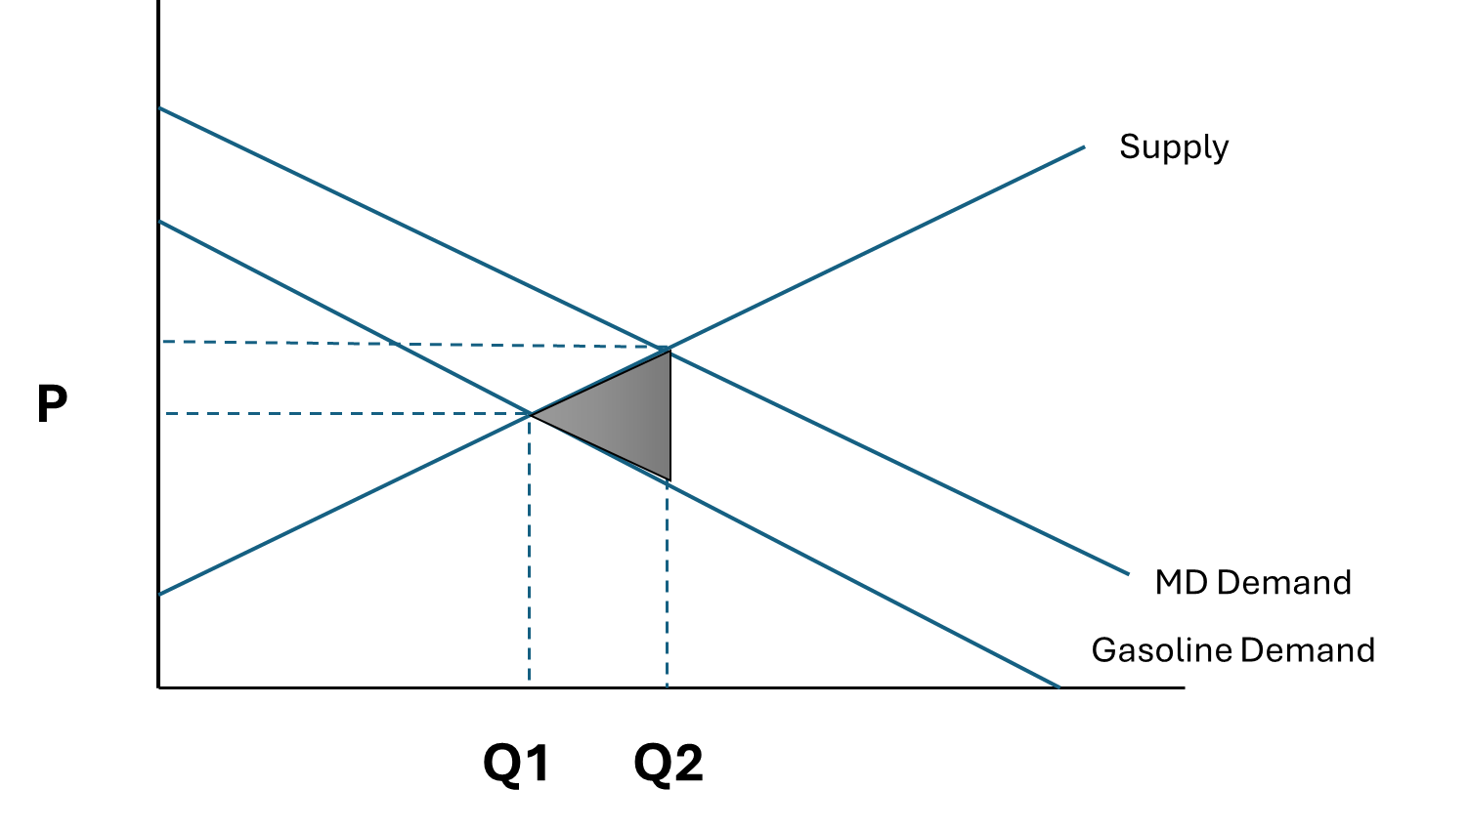
Figure 2: Supply & Demand Under Market Equilibrium
- MCP Part:
The MCP part shows the output level of quantities based on crude supply behaviors and product demand response to reach the market prices. It solves market equilibrium with optimized production levels that balance between objective and constraints. Thus, MCP part looks for the equilibrium quantities of crude and refined products (140,000 bbls/day) and their corresponding prices, providing that all constraints are met (e.g. refinery capacity limit, allocated crude quantity from each source, and each product cut limit)
Further constraints:
Crude mix quantity: $C(s)≤ X_rate(s)$
Main formulas utilized:
- Crude zero profit function:

$$P^{C}s= W(s) {\left(\frac{C(s)}{X_rate(s)}\right)}^{\frac{1}{{Elasticity }_{S}}\left(s\right)}$$

As crude processing increases, its marginal cost goes up based on elasticity value. This means that higher crude supply curve will shift the supply curve upward.

- Refined products zero profit function:

$$P^{d}i= Pavg,i {\left(\frac{∑X\left(i,s\right)}{Q_{avg\left(i\right)}}\right)}^{\frac{1}{{Elasticity }_{D}}\left(i\right)}$$

As demand for Gasoline and MD availability in market increases, their prices decrease, and this aligns with the worldwide practice as supply or product availability increases prices drop and vice versa.
All in all, equilibrium conditions are the point that producers stop increasing output level as marginal benefit equals marginal cost or when the constraints prevent further production (constraints are binding). However, in this model the solution is driven by the maximum refinery capacity constraint of 140,000 bbls/day.
This integrated model of LP, NLP, and MCP provides a clear approach of how refinery operation is optimized under fixed prices (LP), economic welfare (NLP), and full market equilibrium (MCP).

Assumptions Formulation Difficulties, and Data Resources
- Major Assumptions:
- The refinery produces only two products, namely, gasoline and MD.
- Fixed capacity of refinery throughput at 140,000 bbl/day.
- Product yields are limited to 30% and 70 of total crude processed.
- Single period model, in which time change effect is not considered here.
- Optimization is done by single refinery as it is the most cost-effective refinery in the area.
- Neither taxer nor subsidies are considered in the model.
- Constant elasticity of crude supply and petroleum product demand.

- Formulation Difficulties:
Developing the refinery optimization model consists of integrating three components namely, LP model for refinery profit, NLP model for total market welfare, and MCP model for price-quantity equilibrium.
Each component has its own specific mathematical structure. The first difficulty was ensuring that all three models generate consistent and reasonable results for the same economic conditions. The LP model used fixed prices to maximize the profit by allocating the maximum cut for the higher priced product, while NLP and MCP calculate prices through prices and quantities relationships equilibrium.
Another major modeling step is identifying reasonable elasticities (after thorough research), then converting them into slopes of supply and demand, utilizing the average price and average quantities. The benefits of having supply slope and demand slope are to identify the equilibrium point. Upon identifying the slopes, the intercepts of supply and demand can be calculated directly. Using these equations helps identify the market price for the optimal production level. Supply and demand functions are very useful for conducting NLP, as it identifies the total surplus/welfare.
The MCP model can be challenging due to the relationship between prices and quantities as they are sensitive to the estimated supply and demand elasticities. Any shift in production levels could result in major change in prices. The model considers refinery capacity and yield constraints, in which the solver stops when producers and consumers have no incentive to change their decisions.
- Data Resources:
The model used real market data from the U.S. Energy Information Administration (EIA) on petroleum prices. In this case, data for year 2023 and 2024 has been utilized. Average prices US crude, Brent, Gasoline and MD are estimated at $ 73.4/bbl, $ 82/bbl, $ 138.4/bbl, and $ 167.3/bbl, respectively.
Elasticity has been estimated based on real-world common practices, with demand elasticity of 0.58 for gasoline and 0.65 for MD, while supply elasticities of gasoline and MD are set 0.10 and 0.13, respectively. Crude supply elasticity is set at 0.5 for US crude and 0.25 for Brent.

Results Summary & Interpretation:
The model consists of three parts, in which interpretation and discussion of results will be done for each one as shown below:
- LP Part:
The LP model represents the refinery’s short term production outcome under fixed market prices and costs. The objective is to maximize refinery profit while meeting the constraints of capacity limitation (140,000 bbl/day throughput) and product cuts limitations (minimum of 30% and maximum of 70%), as explained in Model Structure section.
The LP results show how refinery optimizes its cuts allocation, giving priority for the higher priced product. Cost of crude processed is calculated based on the weighted average. The refinery allocates its throughput between gasoline and MD according to the corresponding prices at specific time. As MD prices are higher in this case, its production was maximized hitting the upper limit of 98,000 bbls/day, while the balance of 42,000 bbls/day is covered by gasoline (the lower priced product). Below table summarizes the major findings:
Variable | Result
Q_{Gasoline} | 42,000 (bbl/day)
Q_{MD} | 98,000 (bbl/day)
W_avg (weighted cost of crude processed) | $ 75.86/bbl
Total Variable Cost | $ 10.62 million
Fixed Cost | $ 10,000
Revenue | $ 22.21million
$$π$$ | $ 11.58 million

- NLP part:
NLP is an extension for LP structure by introducing price-quantity relationships for demand and supply. Thus, this part uses linear demand and supply curves to maximize the total economic welfare or surplus, instead of dealing with fixed prices and costs.
Basically, the NLP part deals with supply function and demand function, in which it calculates both intercepts and slopes (total of 4 coefficients) that are mainly utilized to find PS and CS. After that, PS and CS are added together to find the TS, which is the economic welfare.
Most important part of NLP is finding the equilibrium output Q* and price P* to move forwards with the above-mentioned calculation, according to the equations mentioned in Model Structure section.
The NLP solution identifies the welfare maximization market equilibrium. The refinery increases its throughput until it reaches the capacity limit of 140,000 bbl/day. Product quantities are identified based on the cut limitations for each product and total demand for both customers, to be exactly matching the total production. Below table summarizes the major findings:

Variable | Result
b | 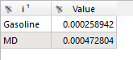
a | 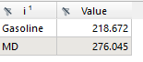
c1 | 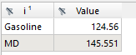
d | 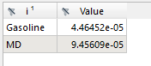
a_c | 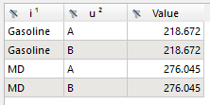
b_c | 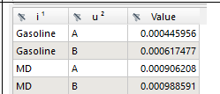
TS | 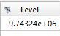

TS here represents the total economic welfare for consumers and producers from gasoline and MD supply/demand balance at the equilibrium quantities.
- MCP part:
The MCP part captures market equilibrium using supply and demand functions. It identifies crude processed (input) and refined product produced (output), and their corresponding prices that satisfy the refinery constraints of throughput and cut limitations, in which constrained optimization is done and it balances between the objective and imposed constraints.
The model assumes no taxes nor subsidies, in which the prices are only affected by market conditions. As equilibrium, demand equals the refinery’s output, and the solver hits the maximum capacity of 140,000 bbl/day, which means that capacity is a major constraint here.
Variable | Result
Equilibrium Production levels | 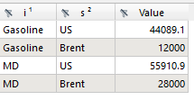
Equilibrium crude processing rate by type | 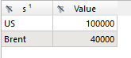
Qtot | 140,000 bbl/day

The MCP results illustrate how each crude source has been processed to produce gasoline and MD in equilibrium. The first outcomes show the production level of each product, in which gasoline production increased to around 56,089 bbl/day compared to LP, while MD production dropped to around 83,911 bbl/day. The reason for that change compared to LP model is that under equilibrium gasoline has higher marginal profit, while MD loses its value much faster. As a result of that, the model shifts production toward gasoline to maximize the economic benefit.
On the other hand, crude is processed based on the available quantities (100,000 bbl/day of US and 40,000 bbl/day of Brent)

Conclusion:
Refinery plays a critical role in the energy sector by processing the crude and converting it to refined products. Such products can be utilized for daily essential needs such as supplying fuels for operating industries, facilitating transportation, and meeting necessary life needs. This comprehensive LP/NLP/MCP model provides a clear picture of how high-technology refinery output and prices behave under several economic conditions. The LP looks for profit maximization under fixed price, showing straightforward calculations, while NLP targets total welfare/surplus maximization. The MCP part handles the full market equilibrium, where quantities and prices adjust until there is no further incentive is generated by neither producer nor consumer.
The next step would be to expand this model beyond a single refinery to cover the entire city or even the country (the entire supply chain network) by including the entire refined products supply chain. Also, it could include all direct effects such as maintenance activities, demand forecast, and sensitivity cases for unforeseen scenarios. Proceeding with this step would allow more reliable and optimized operations, with better customer satisfaction and more reliable operations.
With unlimited time, funding, energy, and personnel, the project would upgrade into a national centralized optimization tool, which is designed to plan and optimize the refined products movement of the entire refined product network within the city and even the country. The objective would be to maximize the overall operational efficiency, reliability, and sensitivity of the refining system to meet the demand sustainably and in a cost-effective manner. Basically, the system finds the most efficient way to meet the whole demand (area, state, or country) by coordinating refineries production levels, pipeline, and shipping routes to maximize operational efficiency, reliability, and cost-effectiveness. Including proper supply means (e.g. pipeline and ships routing) helps meet the entire demand as areas have surplus will supply other areas that have deficit.
The advanced model would integrate multiple refineries production planning, maintenance activity scheduling, storage and distribution logistics, and business continuity strategy into a unified decision-making platform. This can be improved by having a smart tool for maintenance activities scheduling that allocates the proper time for those activities which align with the low demand season. Furthermore, this advanced tool would coordinate how crude oil and refined products move across the supply chain, taking into consideration seasonal demand patterns, prices shocks, unplanned outages in the operational side. In addition, it would include demand forecasting tool using real time information to respond effectively for the sake of predicting accurate demand figures. Overall, the purpose of adding those advanced monitoring and analytic features is to ensure meeting the domestic demand timely, efficiently, and according to the quality standards while minimizing cost and operation downtime. For the long term, this model could become a centralized refined product optimization tool that balances industry operations and environmental regulations, while improving energy security and boosting reliability to a higher level. Furthermore, a KPI could be introduced to measure how operations efficiency and customer satisfaction would improve through this unified and smart system.

